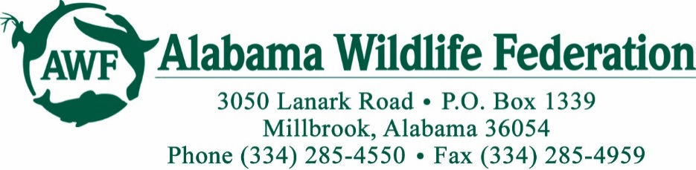

*Alabama Nature Center – Summer Camp Staff Job Announcement and Description*

**BACKGROUND:** The Alabama Wildlife Federation (AWF), located in Millbrook, Alabama, is the oldest and largest non-profit conservation organization in Alabama. The AWF was established by sportsmen in 1935 to promote the conservation and wise use of our wildlife and natural resources and to ensure a high quality of life for future generations of Alabamians. The mission of the AWF is to promote the conservation of Alabama's wildlife and related natural resources, as a basis for the social and economic prosperity of present and future generations, through wise use and responsible stewardship of our wildlife, forests, fish, soils, water, and air. Our organization strives to educate our children about the wonders of Alabama’s outdoors, including our rich natural history and biodiversity, through our Conservation Education programs.

**What is Expedition Lanark Outdoor Day Camp?**

Expedition Lanark Outdoor Day Camp is located at the Alabama Nature Center, part of historic Lanark in Millbrook, Alabama, just 10 miles north of Montgomery and only a couple of miles from I-65. The Alabama Nature Center is a Planned-Use Outdoor Education Facility offering hands-on, outdoor-based educational programs and activities.

The mission of Expedition Lanark is to provide hands-on, outdoor educational activities that teach natural resource stewardship, develop leadership skills, and build character. Day camp sessions begin May 27th and end August 1st. Campers will be ages 5-15. There will be paid training in the month of May.

**POSITION SUMMARY:** The Counselor will assume responsibility for the care and well-being of the campers in their group. Counselors will lead students in daily program classes and be actively involved in all program activities, leading and participating in recreational and instructional times. The Counselor is responsible for teaching outdoor education and natural science programs to groups of children of various ages while maintaining a safe learning environment. The Counselor’s goals are to encourage students’ awareness and appreciation of the environment, broaden the students’ knowledge of science concepts through various activities and games.

**DUTIES:** Responsibilities include but are not limited to the following:

* Assuming responsibility for the care and well-being of campers in their group
* Provide and ensure a safe learning environment
* Supervision and participation in a variety of activities including canoeing, fishing, swimming, and nature hikes, as well as other educational programs and activities.
* Guiding and being responsible for children in a variety of settings and for varying lengths of time
* Setting up and cleaning up for education programs
* Greeting visitors, helping with the gift shop and answering visitor questions
* Being able to navigate to and from the areas of the property where education programs are conducted, including being familiar with our five miles of trails

**POSITION REQUIREMENTS:**

* Ability to set tone and be in control of group you are leading
* Ability to memorize and recall facts, figures, and information and communicate effectively
* Ability to hike on trails, and traverse stairs and uneven terrain while carrying equipment
* Ability to make independent decisions and respond to immediate needs of students, emergency situations, and program needs
* Ability to work outside in a variety of weather conditions and temperatures
* Ability to work well with limited supervision and demonstrate flexibility
* Ability to be reliable and punctual for all programs
* Ability to interact successfully with supervisors, co-workers, teachers, parents and students
* Knowledge of native flora and fauna highly desirable; training provided as needed
* Willingness to handle and care for resident education animals used for programs
* A background check will be required

**WHO MAKES A GREAT Summer Camp Staff CANDIDATE?**

Successful Counselors at the Alabama Nature Center will include people with the following backgrounds:

* Recent college graduates or current students majoring in the fields of wildlife, forestry, biology, zoology, environmental science, education and other natural resource related fields
* Candidates who have a passion for working outdoors with children of various ages
* Professionals trained in the natural resource interpretation field

**PREFERRED QUALIFICATIONS:**

* Candidates would preferably either be working towards or possess a Bachelor's or Associate degree from a four-year college or university with major course work in the natural sciences or education field
* Experience working with children in an educational setting
* American Red Cross First Aid, CPR, Lifeguard and Water Safety Instructor certification
* Knowledge of activities such as fishing, canoeing, archery, swimming, or hiking

**COMPENSATION:**

This position is part-time, hourly, and seasonal that varies in the number of hours offered. Camp session dates are from May 27th -August 1st. Hourly pay for this position will be determined based on qualifications; there is a potential for raises. There are no health or retirement benefits offered with this position.

**SUBMITTALS/INQUIRIES:**

Email a completed application and 1) your resume and 2) three professional references to

Matt Vines  
[mvines@alabamawildlife.org](mailto:mvines@alabamawildlife.org)

Alabama Wildlife Federation

3050 Lanark Road

Millbrook, AL 36054

Application can be found at alabamawildlife.org/AWF-job-announcement

Questions and or requests for additional information should be directed to Matt Vines through the appropriate contact method provided above.

**DEADLINE FOR APPLICATION SUBMITTALS: April 25th, 2025**